**P6 -** Plan an E‐Commerce Strategy

**Introduction**

In this report, I will plan an e-commerce strategy with a design for an e-commerce business. I will discuss the following topics:

* ***E‐commerce strategy*:** structure of site; hosting; promotion; issues e.g. cost, security
* ***Structure:*** *customer interface e.g. ease of use, display of products, personal details entry, credit card entry, other types of payment, delivery details; image; style*
* ***Hosting:*** *choice of ISP; in house or sub‐contracted*
* ***Promotion:*** *marketing e.g. advertising the site, placing in search engines; message board; chat rooms*
* ***Costs:*** *setup; maintenance; security; leasing; advertising; delivery strategy; staff training*
* ***Security:*** *fraud protection; hackers; viruses*

|  |  |
| --- | --- |
| **E‐commerce Consultant:** | Usman |
| **Date:** | 05/03/2015 |

**Structure of site**

Home page

Basket

Log-in

Contact Form

**Customer Interface**

**Home Page**

Basket

BANNER

FOOTER

Logo

Menu Bar

PRODUCTS ANY NEWS

SPECIAL OFFERS

* WATCHES (MEN & WOMEN)
* CLOCKS (ANY SIZE)

THEY HAVE DIFFERENT DESIGNS

Search

This shows the home page the design element of the website that I am going to make. This is a rough sketch of how it is going to be looking like. The logo would be make soon and it would be made on Adobe Photoshop CS5. It will be inserted on each page. This is the page where it will be referred to the other page. The ‘Footer’ is where they will be links referring the page to any social networking sites and any other information that the user would need.

**Contact us**

Basket

Logo

BANNER

**CONTACT US**

**Message?**

**Enquiries?**

FOOTER

Navigation Bar

Search

This will include a page where details will be set out for the user. As any other page, they will be phone numbers, emails and a message page. They can send out any problems they have to us and I can try to fix it. If any occurring message comes out, I will fix that as well. This way it is better and it would improve the site even more. The content will have videos and all of the other features included. As I have said before, the ‘Footer’ is where they will be links referring the page to any social networking sites and any other information that the user would need.

**Checkout**

BANNER

MENU BAR

*PRODUCTS INFORMATION*

*Quantities:*

*TOTAL COST*

PROCEED

FOOTER –OTHER LINKS

Logo

Search

Basket

**Hosting**

**Internet Service Provider**

‐ Which company will provide your Internet? Complete the table to compare the ‘Broadband Packages of each

Internet Service Provider:

|  |  |  |  |
| --- | --- | --- | --- |
| Internet Service Provider | Broadband Speed | Package features | Monthly Price |
| Virgin Media | 152Mb | Big connection 50Mb Broadband with Phone for £5.00 for 6 months. | £12.49 for 12 months |
| Talk Talk | Up to 38Mb | £75 Voucher + £16.70 a month line rental with Free Broadband for 1 year and thereafter £3.50 a month. | £13.50 a month |
| BT | Up to 76Mb | Up to 76Mb Speed with Unlimited usage every month = £25/mth | Lowest at £8/mth to £25/mth |
| EE | 38Mb | £2.50 per month for 12 months plus rental from £11 | £9.95 per month |

* Who have you selected as the internet server provider? And why?

I have selected to choose Virgin Media. I have researched on Virgin Media and some of the customers are very happy with their services. I chose it based on the prices with the speed that I am receiving. Out of all of them, I feel that it is the best deal too.

‐ In house hosting

This means that the website will be run from a webs server within the company and managed by staff with the necessary technical skills to work with websites within the company. You will need to find out about how much it will cost to register a domain name. Find out four different domain name registrars and compare their costs. Here you are buying just the domain name and not web server space or e‐mail addresses.

|  |  |
| --- | --- |
| Domain name registration company | Price (per month or year) |
| .com | £5.99 |
| .co.uk | £3.99 |
| .org | £4.99 |
| .biz | £1.99 |

* Who have you selected and why?

I have chosen **‘.com’** because it is the most commonly used. It is the most expensive out of them all but I feel it is the best choice.

**Web Hosting**

**Sub‐contracted web hosting**

This means that the business will pay another company to create and host the website. Find out how much it would cost to sub‐contract the website to a ‘web hosting company’ that will offer both web server space as well as e‐mail addresses and domain names.

|  |  |  |  |
| --- | --- | --- | --- |
| Domain name registration  company | Web space | Package features | Price (per month or year) |
| .com | 100GB Storage | Unlimited Bandwidth  1 Website with FREE domain | £1.00 / month |
| .co.uk | 10GB | 1 Free .co.uk Domain  10 Sub-domain  FTP access | £2.49 per month (ex VAT at 20%) |
| .org | 50GB | 30 day guarantee money back with 500 starter mailboxes | £0.99/month |
| .biz | 15GB | - | £1.50/month |

‐ Decide whether the e‐commerce website will be hosted in house or sub‐contracted? Explain your choice.

I would want to host my e-commerce website through a company because it will be much better. I would want them to host the website for me. However, I would want a say within it.

**PROMOTION**

Recommend methods of promoting the e‐commerce website for trends. Explain the potential advantages & disadvantages of your chosen methods. Refer to your work on M1.

**SPAM Email**

Email spamming is also known as junk mail, an email that promotes malware. It is a ‘SPAM’ email, because the email is always sent. They never stop. However, if I click on it, I might get malware on my system. It is advised for the user to delete all the junk mail. Anyone can send junk mail. This is a good way to promote my website, because if the user were to click on Tick Tock, he or she would view it.

**Paying for prominence in search result listing**

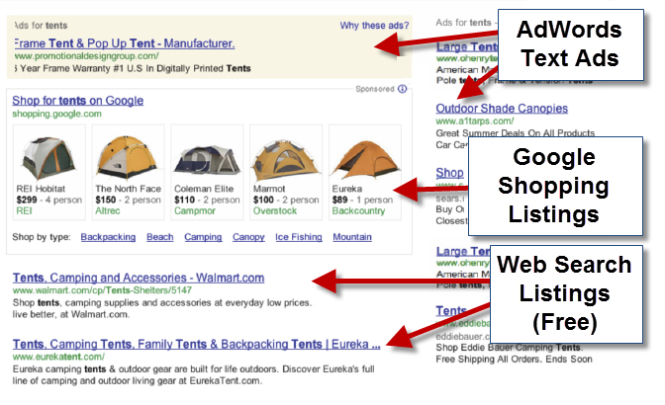One of the main ways an e-commerce can promote their website is by the ranking of the search engine. This is done by paying the search engine to put their website at the top. Some new companies, that have new websites, may be so far down that the user cannot find the information on the website they are looking for. It does not happen straight away. It may take months, or even years, for it to be at the top. It works as a bid. Obviously, for different search engines, it works differently. The bid starts at £0.04 and the highest bidder gets the top rank. They are different ways by using other search engines to promote the website, and this way, it takes longer as well. The picture below shows how the listing works. Tick Tock can use this suggestion and if someone were to type in Tick Tock, there website would appear on Google Search engine; but only if they win the bid.

**Newsgroups and forums**

Newsgroups and forums are a very good way to promote anyone’s websites. Newsgroups are similar to an email account, but the only difference is that everyone can see it. For example, if I were to send a message, on a newsgroup, some people of the community would be able to see it. This is a good way to promote Tick Tock’s website to the community, and the world. Forums is similar too. This is a discussion that most people have with each other. If someone promotes Tick Tock’s website, more people would know it.

**Banners and pop ups**

Banners and pop ups is a form of advertising towards customers around the world. This is done by the banner being linked with the website. Once the banners are created and put on the website, the company can gain more customers. It is the most effective way to promote any website. What the user needs to do is click on the website banner, and it would direct them to the promoting website. This is a classic example of a pop-up. The user has a choice to click on it, or close it. Banners is within the website. Pop ups just simply pops up on the page.



**Site name**

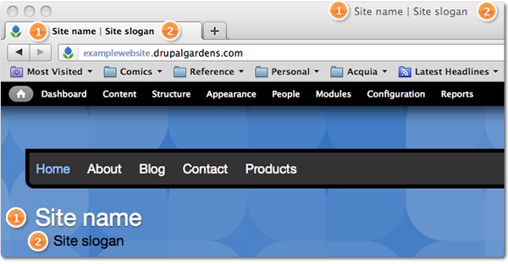Having a simple and unique site name would encourage customers to use the site more. It has to be short and snappy. For example, Tick Tock. This is very short and memorable. It is was to be longer, the customer would not be able to spell it. Some mistakes in it would enable the user not to find the information they were hoping to. All the top brands have it memorable. If Tick Tock were to be Click and Brick, they can hand out leaflets encouraging customers to use their website too.

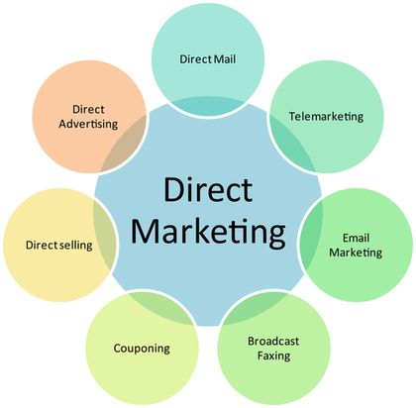**Direct marketing**

This is another effective way to promote any businesses’ website. This is done by directly communicating with the customers. This could be done by calling, texting, emailing, ads, and many more. For example, if Tick Tock would want to communicate with their customers, they would email them. One reason would be that they would want to do a survey. If 10 out of 20 respond, it is good way to improve the website. Thirty-two percent of customers would prefer to be contacting through Direct Marketing.

**Effective use of search engines using Meta tags & ‘spiders’**

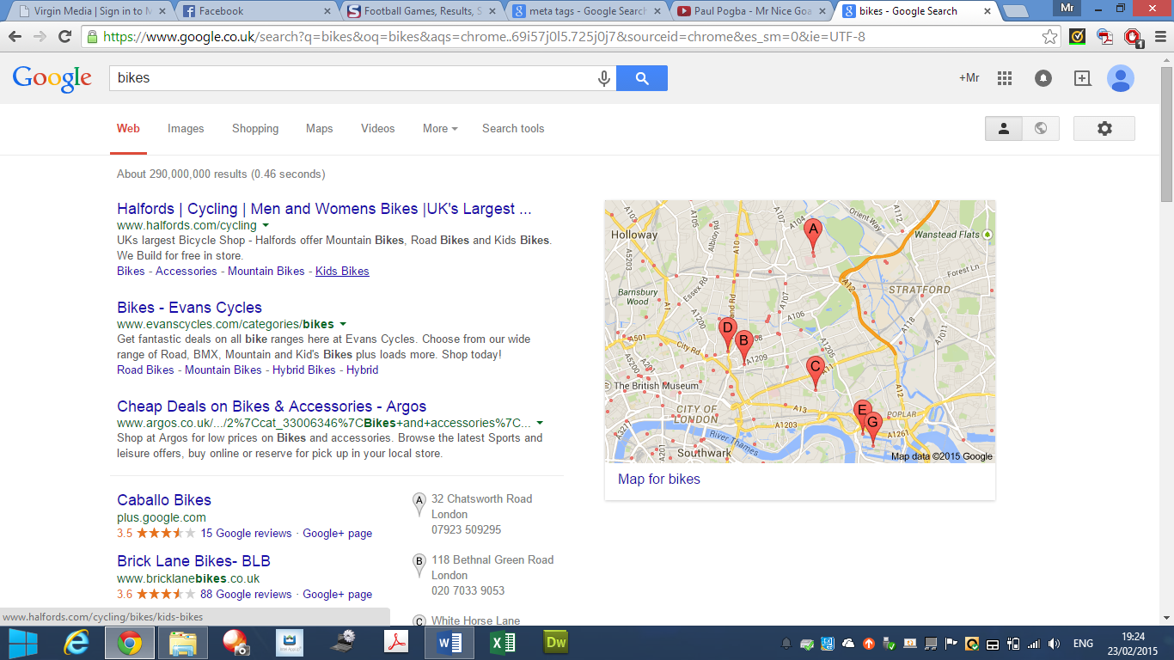Meta tagging is elements within the HTML document that shows information of what is about the web page, which created the page, and which keywords represent the page’s content. It shows varied of content within the tags. This is an effective way to describe what the website is all about. If I were to type in bikes, the search engine would give me a great deal of information for each of the content I am looking for. This image shows us that behind each of the website; it shows what bike I want. It promotes the websites by giving it a brief introduction to the customer.

**Ensuring an effective user interface**

Ensuring an effective user interface allows customers to work around the website easily. If the e-commerce does not look good, it would discourage the customer to not use the website again. The website needs to look professional and easy to use. A person that is not use to using technology would be able to use it. It needs to work simply to gain more customers. A clever technique to use is to zoom the images in within the website. For example, if a person at Tick Tock cannot see properly, the user would be able to zoom it in to have a better look at the product. Small features like these enables more customers using the website more.



**Costs**

**Setup**

The first step for the cost is to set-up the whole system. The three things that we would need to do this is the following:

* Servers
* Server software
* Domain name

The three above would cost. A starting price for servers usually starts at £1000. A target price for purchasing the servers will cost around £1600 to £1700. It will have limited ability to protect the data. The server that runs on the software will be purchased too. This would cost around £900 for the Microsoft SWL Server, and for file sharing, can cost around £400. The domain name would cost around approximately £5. This is the cheapest out of all of them.

**Maintenance**

To maintain a website, I would need a web developer. They would need to be hired and it could take some time to find the best person for the job. Hiring someone to maintain my website can be costly. An annual salary would cost around £24,624 per year.

**Security**

The first software that I will get is Norton. This would cost the company around £60 yearly to stay protected. The first way I will protect my customer’s details is to layer my security. This means my putting security layers on top to find it hard for the hackers to hack into the system; starting with Firewall.

**Advertising**

There are many ways to advertise my website. A free way to advertise is through social networking sites. Around 100 million people use Facebook; this would get around by the owner of the business advertising its page on groups. However, creating leaflets is cheap. Design the leaflet to how I might want it, and print it off. Printing costs per paper. For example, 50 for £17.99. Give it around to any local community and they can view the website. It is better comparing it to other advertising ways.

**Delivery strategy**

I would deliver my goods through Royal Mail. They charge and it varies between it. I would choose Royal Mail, because it is much cheaper than courier service. I would charge delivery for customers. This would be around £2.99 for each product that is delivered.

**Total Costs for running e-commerce websites**

The total cost to running this business would be **= £15,000.**

**Security**

**Viruses**

The technology has increased drastically and they are number of issues that the business needs to become aware. Malware is one of the risks that the business needs to solve. Malware is a malicious software that disturbs the network to gain access to private information of any network. Malware is not just a one virus, but it includes a number of issues such as worms, Trojan horses and spyware. To prevent his from happening, of course, each computer needs to have an anti-virus to get rid of these malicious attacks. Malware could be on what the user uses to on websites i.e. the user visits a website full of malware. Once they click on the ‘fake’ advert, the malware can gain access to the account. To resolve this situation, the IT administrator in the business can prevent and block the website from gaining access to the virus account. In addition, having an anti-virus, it could show the user that the website is safe or unsafe.

**Hacking**

Hacking is someone who seeks to weakness and gains access to a computer system, or a computer network. Hackers are always doing these unexpected results to gain access to the data. The ways that these attacks could happen is by finding out the identified target, potential ways of these attacks and exploiting the system. To protect the data, I can use secure the system by banning unnecessary and unsafe websites that the user explores, scan the system for any viruses, and they are many other ways to secure the system. The effects it has on the e-commerce websites is that they could break into the website by purchasing, or abusing, any customer information that is not right. They could get information from another person’s account, and they could be purchasing products that the user does not even know about.

**Firewalls**

The benefits of using firewall are that it secures the computer network. It disallows other networks from entering your secured network. As it blocks other networks, it blocks viruses and hackers from entering the network. It acts like a secure “wall”. It does not let anything past it. For organisations that have secure data on their computers, it is vital that they tell/ask all employees to keep their firewalls ON. It is important and if anything is let past, it can access the files and the virus can spread/multiple quickly. The disadvantages of using firewall are that it acts like a central point of attack for intruders; and if they are passed firewall, they have access to the whole network. In addition, it only protects one point of it, it does not protect the other parts of it e.g. modem. The effect of using firewall on e-commerce is that it blocks any unauthorised users gaining access to any information that is not allowed by the user. The effect on an e-commerce website is that it can gain access to all of your information if the firewall has been broken in too. This needs to be looked after too, as well as the computer.

**M3 - Design an interface for an e‐commerce business**

1. Evaluate the following two e‐commerce interfaces using the checklist provided:

|  |  |  |
| --- | --- | --- |
| **Website 1:** <http://www.onestopphoneshop.co.uk/> Examine the homepage and then answer the following  questions: | | |
|  | Is there a search box  facility? | Yes  No  |
| If yes, is it clearly positioned? | Yes  No  |
| Is there an option to  browse through the category of products quickly? | Yes  No  |
| Does the website have  a simple navigation bar which is suitably located? | Yes  No  |
| Is the shopping basket  clearly visible on each page? | Yes  No  |
| Does the homepage  display special offers and new arrivals? | Yes  No  |
| Is the size of the  pictures appropriate? | Yes  No  |
| Is the webpage  download speed appropriate? | Yes  No  |
| Is the content spaced  out suitably? | Yes  No  |
| Was the website easy  to use? | Yes  No  |
| Would you purchase a  phone from this website? | Yes  No  |

|  |  |  |
| --- | --- | --- |
| **Website 2:** <http://www.carphonewarehouse.com/> | | |
|  | Is there a search box  facility? | Yes  No  |
| If yes, is it clearly positioned? | Yes  No  |
| Is there an option to  browse through the category of products quickly? | Yes  No  |
| Does the website  have a simple navigation bar which is suitably located? | Yes  No  |
| Is the shopping  basket clearly visible on each page? | Yes  No  |
| Does the homepage  display special offers and new arrivals? | Yes  No  |
| Is the size of the  pictures appropriate? | Yes  No  |
| Is the webpage download speed  appropriate? | Yes  No  |
| Is the content spaced  out suitably? | Yes  No  |
| Was the website easy  to use? | Yes  No  |
| Would you purchase  a phone from this website? | Yes  No  |

**Which e‐commerce website would you prefer to shop at?**

Website 1  Website 2 

**List three design features that make your chosen website a ‘Good’ e‐commerce website.**

• Feature 1: Clear

• Feature 2: Positioning

• Feature 3: Menu Bar

2. Now design an e‐commerce interface for ‘_____’ in PowerPoint. The designs must cover the homepage, a page of your choice and a checkout page.

|  |  |  |  |
| --- | --- | --- | --- |
|  | **Page 1: Homepage** | **Page 2: Page of your choice** | **Page 3: Checkout page** |
| Is there a search box facility? | Yes | Yes | Yes |
| Is it in the same place on each page? | No | No | No |
| Is there an option to  browse through the category of products quickly? | Yes | No | No |
| Does the website have a simple navigation bar which is suitably and consistently located on each page? | Yes | Yes | Yes |
| Is the shopping basket clearly visible on each page? Is it in the same place? | Yes and no it is not in the same place | Yes and no it is not in the same place | Yes and no it is not in the same place |
| Does the homepage display special offers and new arrivals? | Yes | No | No |
| Is the size of the pictures appropriate? | Yes | Yes | Yes |
| Is the webpage download speed appropriate? | Yes | Yes | Yes |
| Is the content spaced out suitably? | Yes | Yes | Yes |
| Is the interface easy to use? | Yes | Yes | Yes |
| Is there use of consistent house style? | Yes | Yes | Yes |